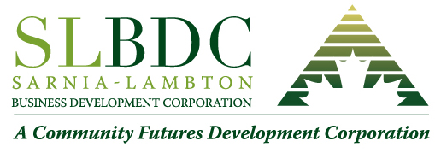
Client Attestation for
Labour Costs and COVID- 19 Wage Subsidies
As designated financial authority, I attest that [Company Name] has not received support through the following federal support measures in the last year:
  - Business Credit Availability Program (BCAP);
  - Canadian Emergency Business Account (CEBA);
  - Canadian Emergency Commercial Rent Assistance (CECRA), Canada Emergency Rent Subsidy or other rent relief provided through our organization’s landlord;
  - Canada Emergency Wage Subsidy (CEWS);
  - Canada Revenue Agency (CRA) Temporary 10% Wage Subsidy;
  - Service Canada Work-sharing program;
  - National Research Council of Canada Industrial Research Assistance Program (NRC IRAP) Wage Subsidy;
  - Indigenous Business Support Loans;
  - Highly Affected Sectors Credit Availability Program (HASCAP)
  - Business Development Bank of Canada (BDC) Co-Lending Program for SMEs; or
  - Other federal or provincial programs/grants;
  - Ontario Small Business Grant;
  - Regional Recovery and Relief Fund,

for labour, wage costs, or any other expenses included in our Application for Funding to Sarnia-Lambton Business Development Corporation .
Further, I attest that I have not made an application to, or have received support from, the Regional Relief and Recovery Funds (RRRF) as administered by the Federal Economic Development Agency for Southern Ontario (FedDev Ontario), or any other Regional Development Agency (RDA) in Canada.

Name: ________________________________
Position: _______________________________
Company: ______________________________
Date: __________________________________

